AUGUST 21, 2019

PASADENA SOCIETY OF ARTISTS PRESENTS
ARTIST’S CHOICE EXHIBITION SEPTEMBER 3-28 AT WHITE’S GALLERY, MONTROSE, WITH SILENT AUCTION FOR STUDENTS SEPTEMBER 14

The Pasadena Society of Artists is proud to present more than 70 artworks in our Artist’s Choice Exhibition September 3-28 at White’s Fine Art Gallery located at 2414 Honolulu Avenue in Montrose.
Meet the artists and learn about their artwork at the Opening Reception Saturday, September 14, 4 pm to 6 pm. Refreshments and hors d’oeuvres will be served. In addition, PSA will host a SILENT AUCTION of small works for Theatre of Hearts before and during the Opening Reception.

Gallery hours are Tues.–Sat., 9 am to 5 pm. The gallery can be contacted at 818-957-4071 or at whitesfineart.com.

About the Show
Each artist has selected the very best of their most recent work for this exhibition.

Presenting artists include Andrea Abonyi, Michael Childs, Patti Coyle, Alison Davies, Rick Drobner, Martin Ehrlich, Mims Ellis, Mina Ho Ferrante, David Grigsby, Laura Henneforth, Karen Holgerson, Dorothe Horttor, Leah Knecht, Sonali Kolhatkar, Joanna Kos, Robert I Kutner, Patricia Lee, Jim Marshall, Peter McDonald, Emily Nunez, Debbi Swanson Patrick, Victor Picou, Rebecca Harvey Pollack, Margaret Raab, S. A. Smith, Tsvetelina Valkov, Marian Westall, and Bryn Ziegler.

Media include oils, acrylics, watercolors, photography, mixed media, ceramics, collage, assemblage, collagraphs, monoprints and others. Artwork includes abstract, representational, landscapes, drawings, fantasy, and more.

As a special event, PSA is responding to the current status of national affairs by raising funds and awareness for the youth served by Theatre of Hearts. PSA will manage all sales of the silent auction with 100% of funds being donated to Theatre of Hearts. Bidding will start at $20, and pieces will be marked with a “buy it now” price to encourage purchases. The auction runs from 3 to 6pm, September 14.

About Theatre of Arts
The mission of Theatre of Hearts is to prevent and intervene in violence through arts education workshops for youth, offered at schools and detention centers in underserved neighborhoods throughout Los Angeles County. Programs focused on tolerance and intercultural understanding, are conducted by professional artists, dancers, musicians, writers, and performers.

PSA
Founded in 1925, the Pasadena Society of Artists is one of the area’s original professional artist groups. The Society is noted for its vigorous, active membership, wide diversity of artistic statement, and high professional standards. Membership is by juried submission.

PSA is a non-profit organization whose mission is to present the works of its many talented artists to the community of Pasadena and surrounding areas. Combining an active tradition of community participation and partnering with local community arts organizations, as well as philanthropic, humanitarian and educational institutions, PSA endeavors to enhance public awareness of art and the enriching qualities it brings to our lives. For more information about PSA please visit PasadenaSocietyofArtists.org

Contact: Debbi Swanson Patrick, 310-995-5389
Individual images available. Please call or email writerphotodeb@gmail.com

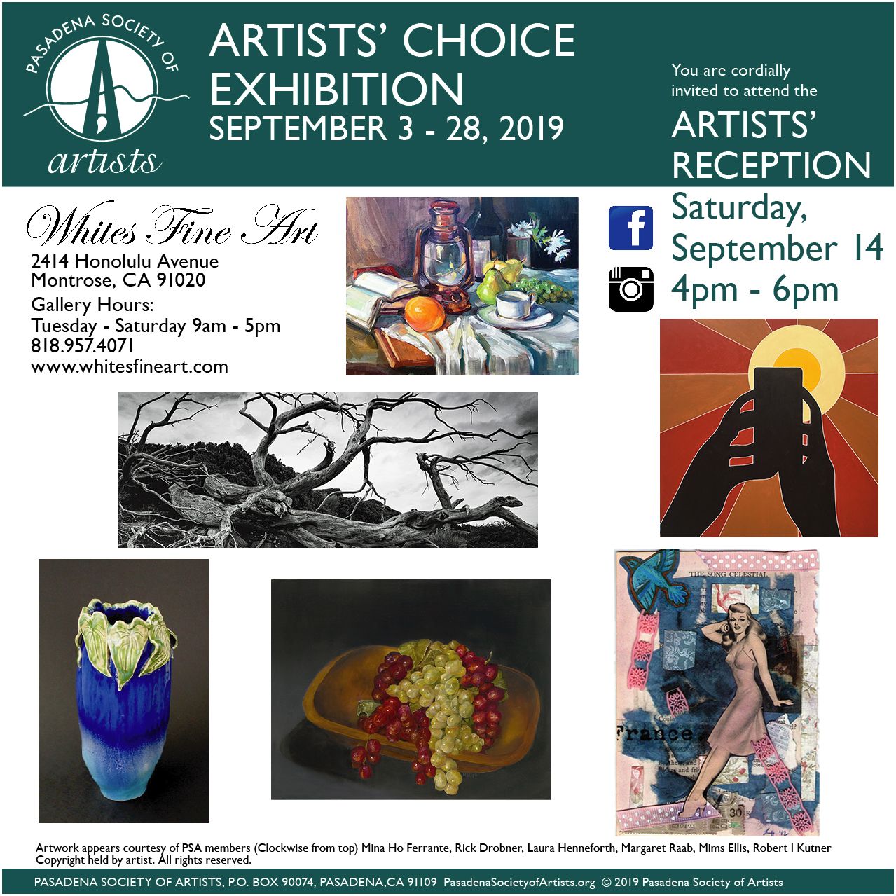

P.O. BOX 90074, PASADENA, CALIFORNIA 91109
PasadenaSocietyofArtists.org

