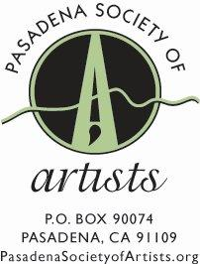
The Pasadena Society of Artists
Awarded several honors at
the 95th Annual Juried Exhibition
at White’s Fine Art Gallery in Montrose

The following were awarded prizes at the Pasadena Society of Artists 95th Annual Juried Exhibition, still running through December 31at www.pasadenasocietyofartists.org.

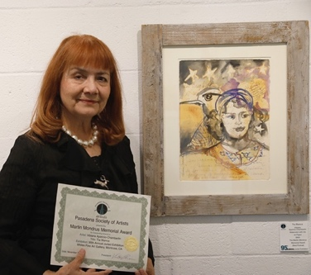
Vibiana Aparicio-Chamberlin,The Martin Mondrus Memorial Award for Best Portrait
Title: Tia Blanca
Watercolor with Ink on Paper

About the award:
Martin Mondrus was a printmaker, painter, and a PSA Distinguished Artists during his 50-plus years as a member of PSA. He studied at ArtCenter, Claremont Graduate School, Otis Art Institute, and Atelier 17, in Paris. He was a professor of art at Glendale Community College and a member of the Los Angeles Printmaking Society.

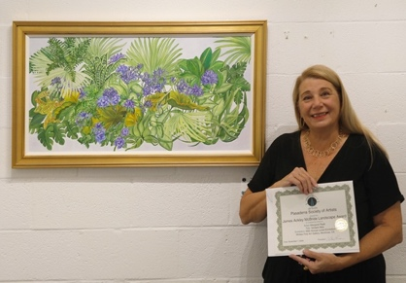
Margaret Raab, The James Ackley McBride Landscape Award
Title: Verdant Web
Oil on Board

About the award:
This award has been given to a selected artist at every PSA Annual Exhibition since the late 1920s. Dr. and Mrs. McBride established the award in the memory of their son, James Ackley McBride who served in the French Army during WWI, then the American Expeditionary Force and a 1st Lieutenant and pilot in the 9th Aero Squadron on the Western Front. He died October 6, 1918, and is buried in Argonne Remy cemetery in Europe. Mrs. Eva McBride was an oil and watercolor landscape painter and one of the founders of the Pasadena Art Institute which was located in the Reed mansion in Carmelita Park, on the northeast corner of Orange Grove and Colorado Blvds.

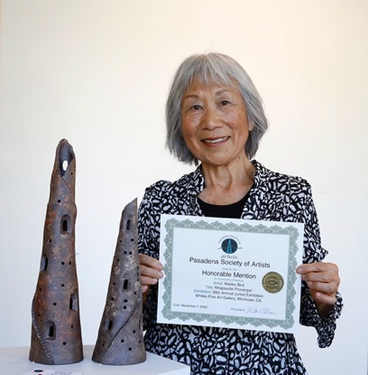
Mariko Bird, Honorable Mention Award
Title: Rhapsodie Provençal
High Fire Ceramic

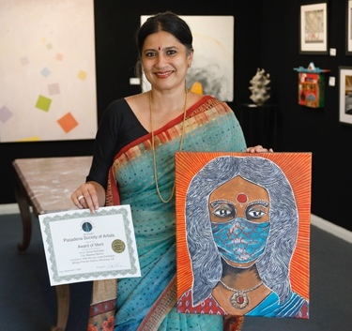
Sonali Kolhatkar, Award of Merit
Title: Masked Warrior
Acrylic on Canvas

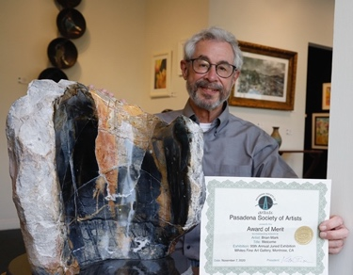
Brian Mark, Award of Merit
Title: Welcome
Sculpture in Picasso Marble

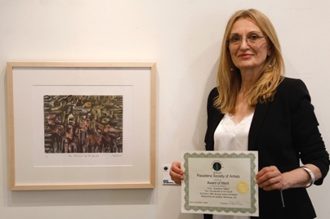

Tsvetelina Valkov, Award of Merit
Title: "The Benefit of the Doubt"
Etching, Aquatint and Watercolor Monoprint

Awards without photos of artist:

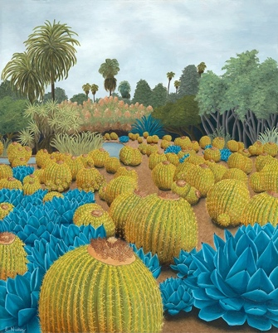
Emily Suñez, The Chantal Giddens Memorial Award for Best Painting
Title: Golden Barrel Sea
Oil on Canvas

About the award: Chantal Giddens was born and educated in France. She studied in Bordeaux, Hong Kong, London and Los Angeles, notably under artist Douglas Bond. She embraced diverse cultures. Her love for Asian design, combined with a passion for myth and fairy tales, were primary elements in her paintings.

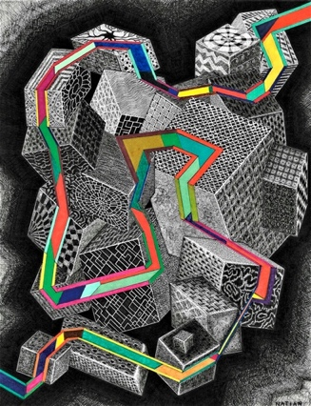
Albert Natian, Honorable Mention
Title: Many Worlds Interpretation
Pen and Ink on Paper
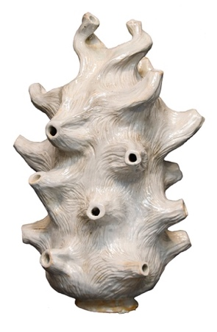
Nancy Wood Pink, Honorable Mention
Title: Taking it All In
Glazed High-fire Stoneware

About PSA: Founded in 1925 by a group led by “the dean of Pasadena painters,” Benjamin Brown, the Pasadena Society of Artists is one of the area’s original professional artist groups. The Society is noted for its vigorous, active membership, wide diversity of artistic statement, and high professional standards. Membership is by juried submission.

For more information:
Contact Director of Communications, Debbi Swanson Patrick, 310-995-5389. Individual images available. Please call or email news@pasadenasocietyofartists.org

FaceBook: https://www.facebook.com/PasadenaSocietyofArtists/
Instagram: https://www.instagram.com/pasadenasocietyofartists
Twitter: https://twitter.com/PasadenaArtists
PSA online: https://www.pasadenasocietyofartists.org/news_events/calendar.html

