For immediate release
PSA participated in the 2017 Pasadena Community College, Visual Arts and Media Studies Division Scholarships.
June 1st, 2017, at 12:00 pm The awards presentation and opening art reception will be at the PCC Boone Art Gallery, Pasadena City College 1570 E. Colorado Blvd. Pasadena, CA 91106. The Boone Art Gallery is in the Center for the Arts. $2 parking fee. All are welcome
On behalf of the membership of PSA, the Board of Directors awarded two $300 cash scholarships to the first and second place PCC art students. PSA will also award a one-year complimentary PSA membership for the first, second and third place winners. Also Mr. Jay Belloli, Interim Director of Pasadena Museum of California Art, offered an annual membership to PMCA to these 3 talented students.
Susan Lai 1st Place (+cash award)
Monica Thong 2nd Place (+cash award)
Jessica R. Merino 3rd Place

The winning students are invited to exhibit free of charge in the new members exhibition in January 2018 in Burbank. Secondly, we welcome them to attend a PSA meeting this summer to show off their work at the Woman’s City Club, 160 N. Oakland Ave, Pasadena, CA.

Gina Fernandez, Rene Hoffman and Alice Dworkin, served as jurors for the
VAMS 2017 PSA Scholarship Portfolio reviews.

PSA, founded in 1925, is a non-profit organization that actively cultivates art appreciation and education within the community with over 150 members in the greater Pasadena area.

Non-members and art students are always welcome to attend our monthly membership meetings at the Women’s City Club of Pasadena. Meeting schedule and times are posted on our website, www.pasadenasocietyofartists.org
For more information contact Pasadena Society of Artists
P.O. Box 90074
Pasadena, CA 91109
info@PasadenaSocietyofArtists.org
#####
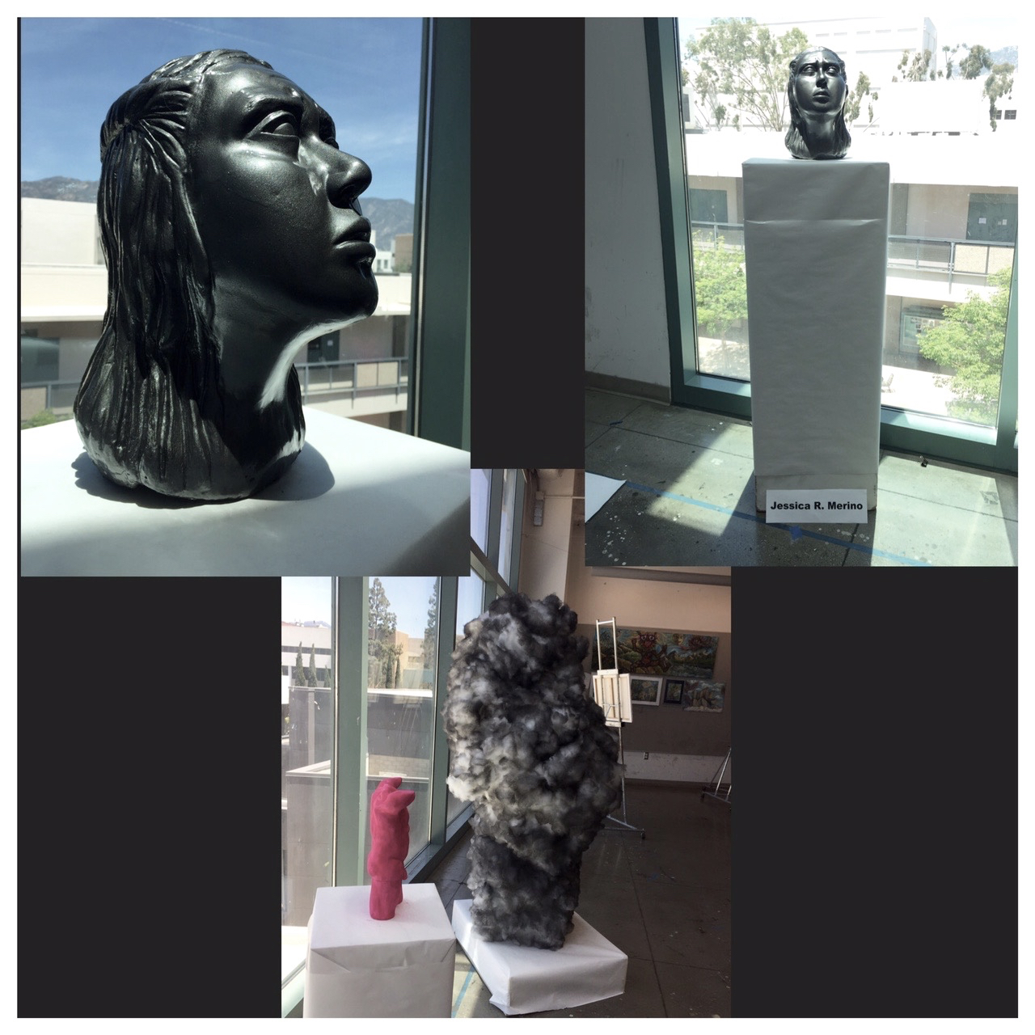
Jessica R. Merino 3rd Place
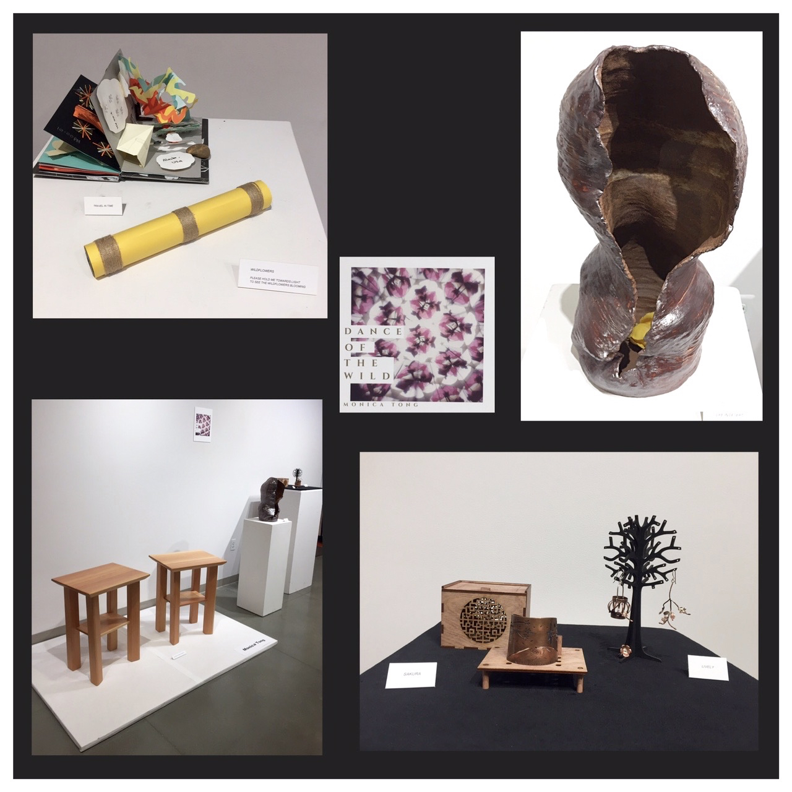
Monica Thong 2nd Place
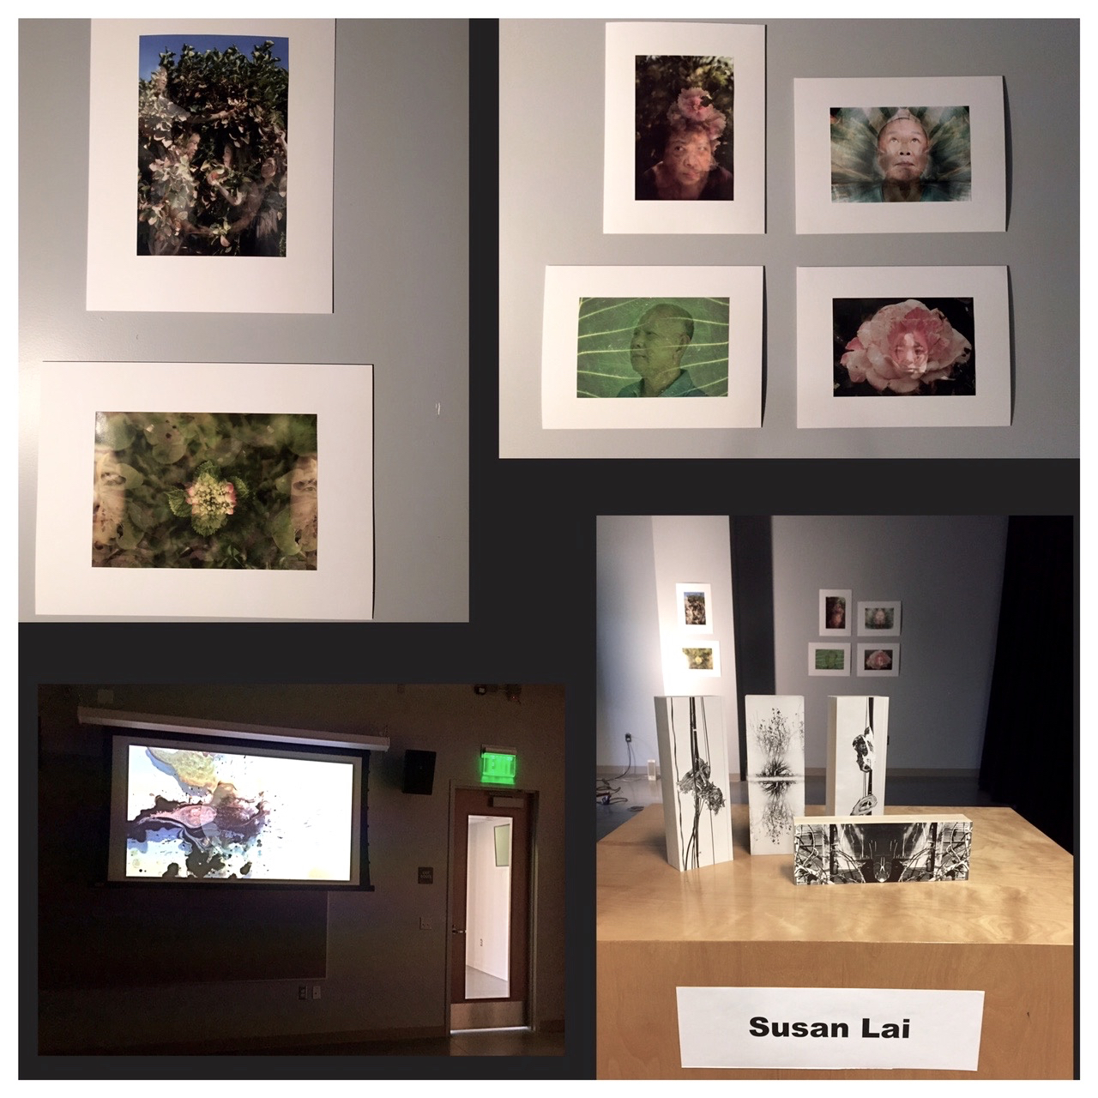
Susan Lai 1st Place

